**Minor Project Report**

**Submitted in partial fulfilment of the degree of**

**BCA**

**By**

**Debojyoti Das (31101220040)**

**Third year student of**

**Guru Nanak Institute of Technology**



**Under the supervision of**

Mr. Mainak Deb

**Sikharthy Infotech Pvt. Ltd.**

**Department of Computer Application**

Date:

I hereby forward the documentation prepared by me **Debojyoti Das** under the supervision of Mr. Mainak Deb Sir entitled **Result Management System Website/Portal** accepted as fulfilment of the requirement for the Degree of Bachelor of Computer Application (BCA) in **Computer Application** from **Guru Nanak Institute of Technology** affiliated to **Maulana Abul Kalam Azad University of Technology** (**MAKAUT**).

|  |  |
| --- | --- |
| ______________________________    **Mr. Mainak Deb**  **(Senior Software Engineer & Project Manager)**    **Project Guide**  **Sikharthy Infotech Pvt. Ltd.** | ____________________________________    **Debojyoti Das**  **Department of Computer Application**  **Guru Nanak Institute of Technology** |

**Result Management System Website/Portal**

By

**Debojyoti Das (31101220040)**

UNDER THE GUIDANCE OF

**Mr. Mainak Deb**

**Project Guide**

**Sikharthy Infotech Pvt. Ltd.**

THEIS SUBMITTED IN FULFILLMENT OFTHE REQUIREMENTS FOR THE DEGREE OF

**B.C.A**

IN

COMPUTER APPLICATION

**GURU NANAK INSTITUTE OF TECHNOLOGY**

**AFFILIATED TO**

**Maulana Abul Kalam Azad University of Technology**

[**Address**](https://www.google.co.in/search?rlz=1C1GTPM_enIN734IN734&biw=1366&bih=613&q=future+institute+of+technology+address&stick=H4sIAAAAAAAAAOPgE-LVT9c3NEyrMC-JTzbO0JLNTrbSz8lPTizJzM-DM6wSU1KKUouLAYQ6jCEwAAAA&sa=X&ved=0ahUKEwi3htjS0_rbAhVLQY8KHTJnC-kQ6BMI1wEwEQ)**:**157/F, Nilgunj Rd, Sahid Colony, Panihati, Kolkata, West Bengal 700114

[**Phone**](https://www.google.co.in/search?rlz=1C1GTPM_enIN734IN734&biw=1366&bih=613&q=future+institute+of+technology+phone&sa=X&ved=0ahUKEwi3htjS0_rbAhVLQY8KHTJnC-kQ6BMI6gEwEw)**:**[094320 12681](https://www.google.com/search?q=gnit&oq=GNIT&aqs=chrome.0.35i39i355j46i39j69i59j0i512j0i131i433j46i131i175i199i433j0i512l4.1811j0j15&sourceid=chrome&ie=UTF-8)

**Email:**

**Website**: gnit.ac.in

**Certificate of Approval**

The foregoing project is hereby approved as a creditable study for the BCA in Computer Application and presented in a manner of satisfactory to warrant its acceptance as a prerequisite to the degree for which it has been submitted. It is understood that by this approval the undersigned do not necessarily endorse or approved any statement made, opinion express or conclusion therein but approve this project only for the purpose for which it is submitted.

Final Examination for

Evaluation of the Project ----------------------------------------

-----------------------------------------

------------------------------------------

Signatures of Examiners

**ABSTRACT**

The purpose of the project entitled as “Result Management System Website” is to develop a webpage which is user friendly simple, fast, and cost effective. It deals with the management of student details and their results etc. The main function of the system is to store student details. The “Result Management System Website” has a dishes section, from where users can check or download results. Admin can add, update or remove any from admin panel.

**ACKNOWLEDGEMENT**

It is a great pleasure for me to acknowledge the assistance and participation of a large number of individuals to this attempt. Our project report has been structured under the valued suggestion, support and guidance of **Mr. Mainak Deb**. Under his guidance we have accomplished the challenging task in a very short time.

Finally, we express our sincere thankfulness to our family members for inspiring me all throughout and always encouraging us.

**Debojyoti Das**

**Department of Computer Application**

**TABLE OF CONTENTS**

Chapter 1: Introduction

1: Introduction

Chapter 2: What We Used

2.1: JAVA

2.2: Frontend

2.3: IDE

2.4:JAVA SERVLET

2.5: MYSQL

Chapter 3: Functionality of the Website

3.1: User Login Page

3.2: User Signing Page

3.3: User Dashboard Page

Chapter 4: FEATURES

4.1: User

Chapter 5: System Analysis

5.1: Identification of the need

5.2: Preliminary Investigation

5.3: Feasibility Study

Chapter 6: Project Planning and Scheduling

Chapter 7: Functional Requirement of the System

7.1: Hardware Requirement

7.2: Software Requirement

Chapter 8: Database Design

8.1: Data Dictionary

Chapter 9: Conclusion

Chapter 10: References

**INTRODUCTION**

Online Student Result Management System is a website created specifically for accessing Result of student examination. This method will help teachers to publish all students result and student can easily access their result. The technology also enables for the quick and easy management of an online result that Students can see and download from with just a few mouse clicks.

**2.1 Java**

We used java 14, in this project we learned java datatypes, methods, class, sorting, OOPs concept, loops and many elements in our java program.

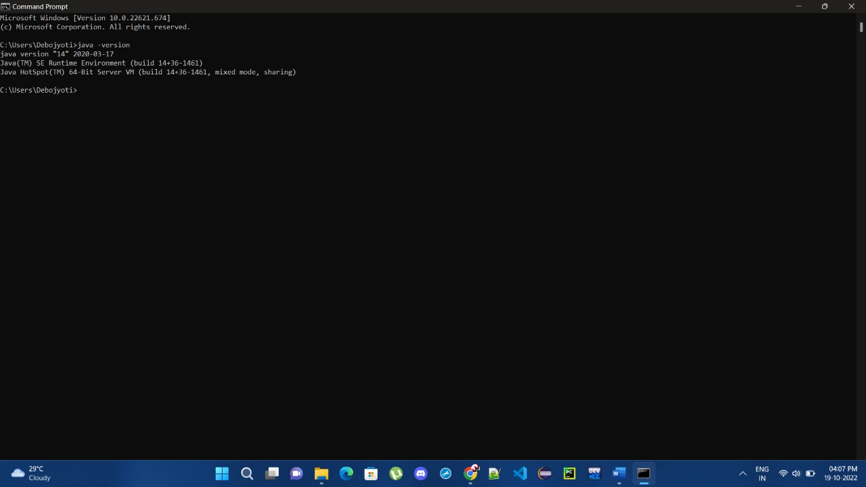

**2.2Frontend**

We used HTML-5, CSS-3 and Bootstrap in this project.

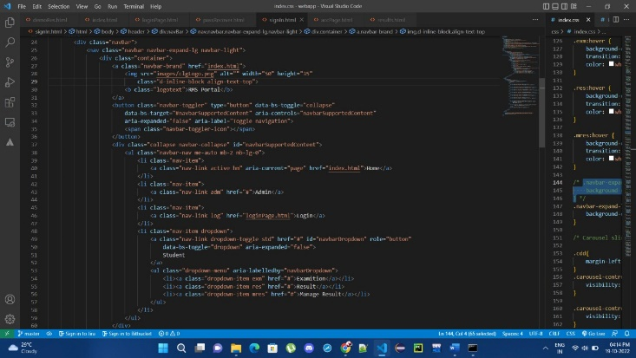

**2.3IDE**

We used Microsoft Visual Studio Code (VS Code), eclipse in our project as IDE.

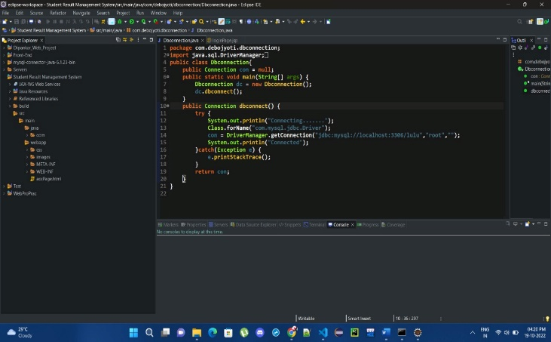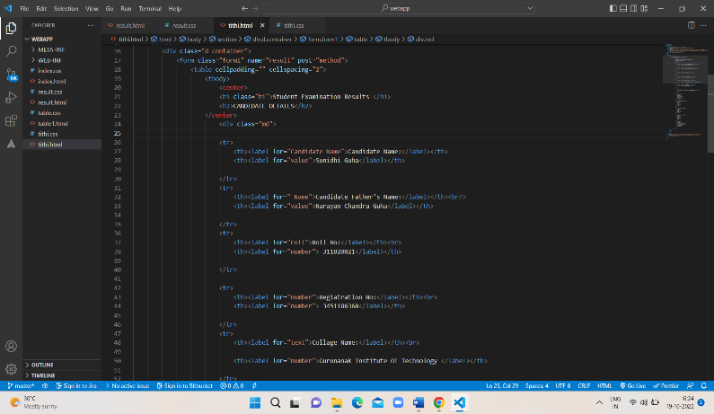

**3. FUNCTIONALITY OF THE WEBSITE**

**3.1USER LOGIN PAGE**

This is the simple login page for the users. They can login by entering their registered username and password.

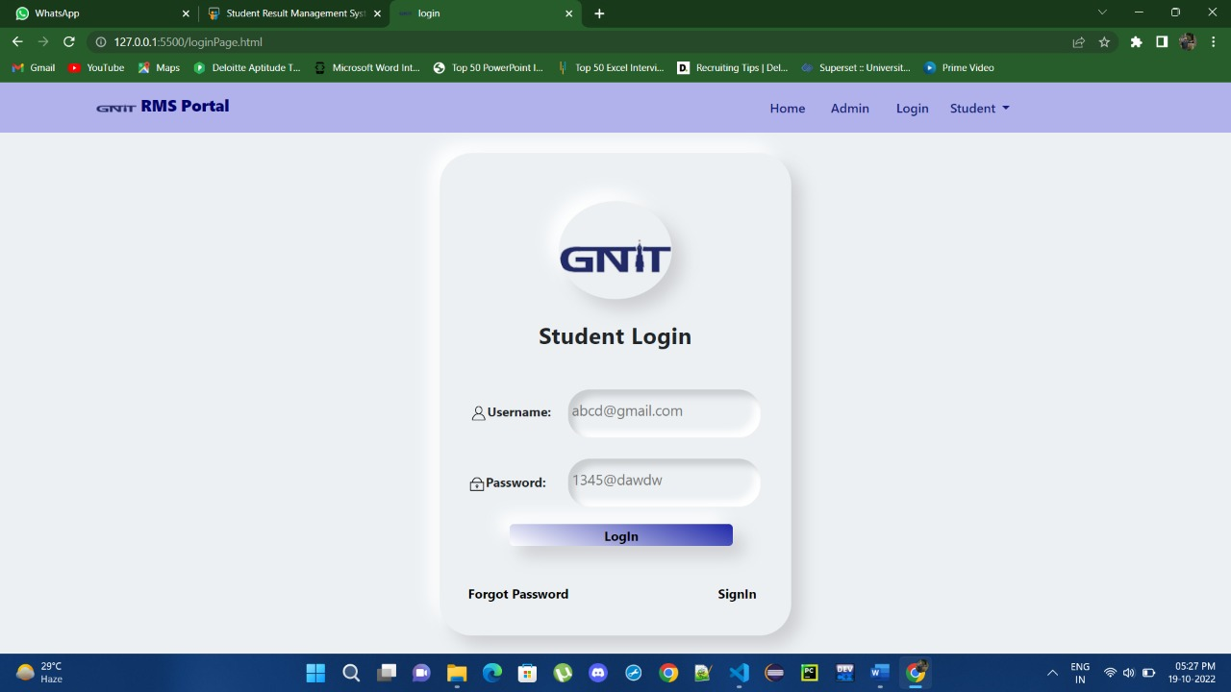

**3.2USER REGISTRATION PAGE**

The users can register a new account with their name followed by their First name, address, university roll, registration number, Email, Username, phone number, Address setting a password for their account.

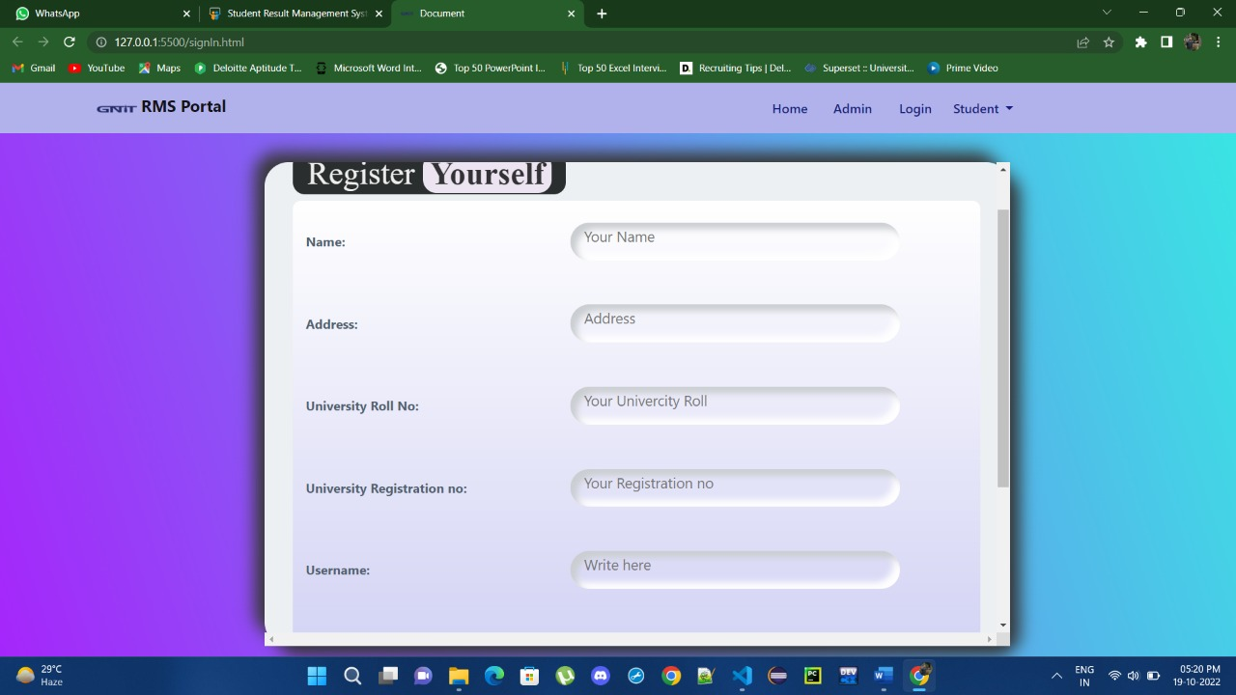

**3.4 USER DASHBOARD PAGE**

Here user can access their account to download their result.

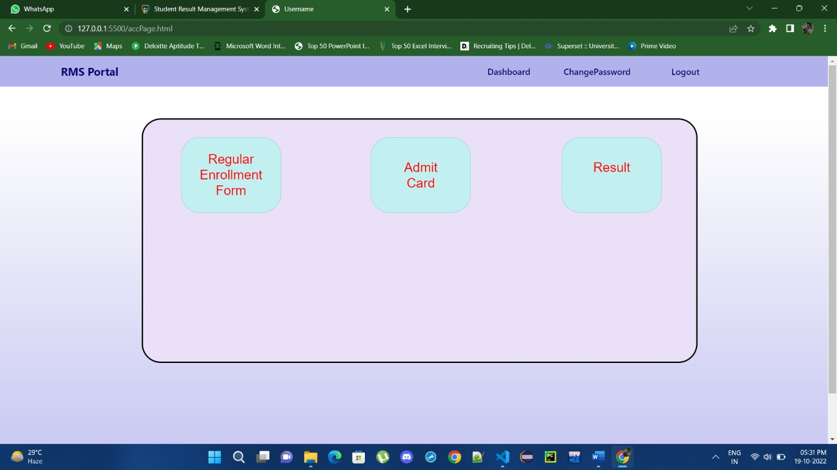

**3.5 MANAGING RESULTS**

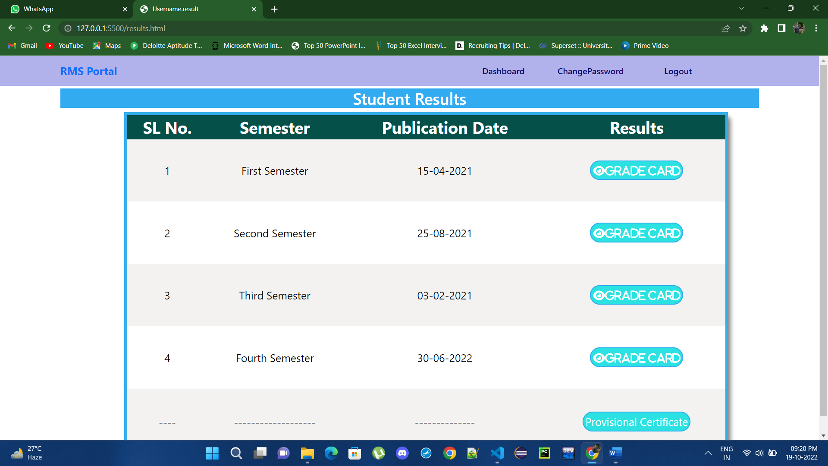

**3.6 RESULT PAGE**

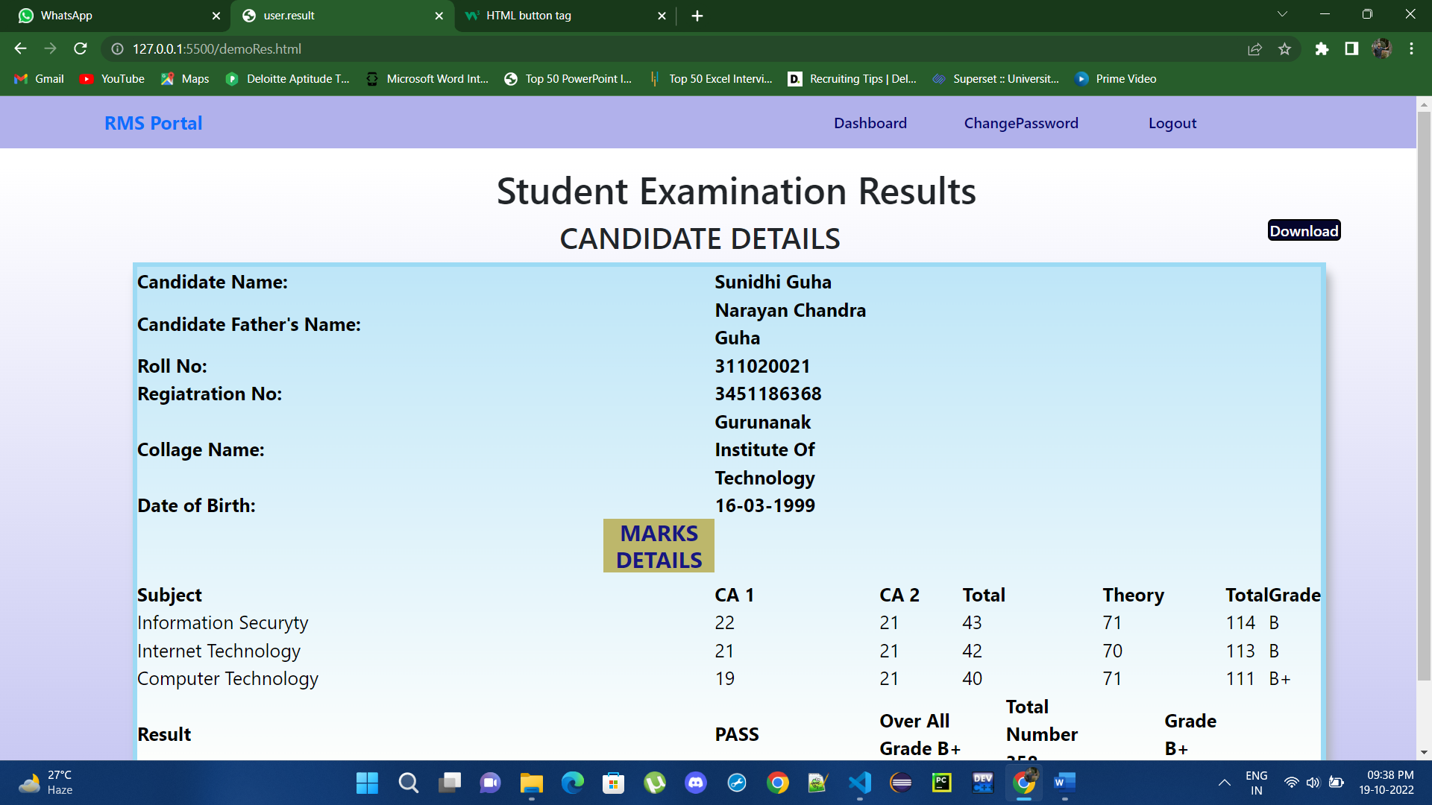

**4. FEATURES**

**4.1 ADMIN**

* User Dashboard.
* User can access result.
* User can access/download result.
* User can change own password.

**4.2 USERS**

* Users can view result section and can download.
* They can create account and login

**5. SYSTEM ANALYSIS**

**5.1 IDENTIFICATION OF NEED**

At the behind of any project, there are mainly two important parts i.e. Proper Plans and Right execution of those plans. This is the key of success. That will always help to execute the ideas.

Here that same process we followed during that development. We made the plan of making this **Student Result Management System Site** to make it easy for the users to access their result and manage/download them.

**5.2 PRELIMINARY INVESTIGATION**

Preliminary investigations involve collecting information that helps to evaluate the merits of a project and make an informed judgement about the feasibility of the proposed project.

While we planned about **“STUDENT RESULT MANAGEMENT WEBSITE”,** on the Internet a lot of consideration was given to all these issues. Extensive thought was given to the various minimum-offering levels that can be provided against the possible returns from such offerings.

**5.3 FEASIBILITY STUDY**

The feasibility of the project is analysed in this phase and business proposal is put forth with a very general plan for the project and some cost estimates. During system analysis the feasibility study of the proposed system is to be carried out. This is to ensure that the proposed system is not a burden to both the public and the company. For feasibility analysis, some understanding of the major requirements for the system is essential. Three key considerations involved in the feasibility analysis are:

**5.3.1 Economic Feasibility**

This study is carried out to check the economic impact on the system of the organization. The amount of fund that the company can pour into the research and development of the system is limited. The expenditures must be justified. Thus, the developed system as well within the budget and this was achieved because most of the technologies used are freely available.

**5.3.2 Technical Feasibility**

This study is carried out to check the technical feasibility i.e. the technical requirements of the system. Any system developed must not have a high demand on the available technical resources. This will lead to high demands being placed on the client. The developed system must have a modest requirement, as only minimal or null changes for implementing this system.

**5.3.3 Operational Feasibility**

The aspect of study is to check the level of acceptance of the system by the user. This includes the process of training the user to use the system efficiently. The user must not feel threatened by the system, instead must accept it as a necessity. The level of acceptance by the users solely depends on the methods that are employed to educate the user about the system and to make him familiar with it.

**6.Project Planning and Scheduling**

Scheduling is an important activity of any project management. Scheduling a software project involves first breaking down an entire problem into a logical set of tasks which would be assigned to developers.

In order to Schedule the “**STUDENT RESULT MANAGEMENT WEBSITE**” we have to do the following:

▪ Identify the tasks needed to complete the project.

▪ Determine the dependency among different tasks.

▪ Establish the most likely estimates for the duration of the identified tasks.

▪ Plan the starting and ending dates for various tasks.

▪ Determine the critical path i.e. the chain of tasks that determine the duration of the project.

**7. Functional Requirement of the System**

Being a web-based solution the first and foremost thing that starts acquiring importance in this project is the way the complete package needs to be configured. Web-based solutions by virtue of their designs are mostly thin client solutions (unless they are heavy on DHTML). To run this kind of a solution properly it is necessary that the Server configurations are properly worked out. It is the server that will have to ultimately scale up as and when the numbers of users start increasing.

**7.1 HARDWARE REQUIREMENTS**

The minimum Hardware requirements for the application to run smoothly should have the following configuration:

|  |  |
| --- | --- |
| **Processor** | Intel Core i3 |
| **RAM** | 4GB or more |
| **HDD** | 3GB or more |

**7.2 SOFTWARE SPECIFICATIONS**

The minimum software requirements are as follows:

|  |  |
| --- | --- |
| **Operating System** | Windows 7,8 and upwards |
| **Database** | MySQL |
| **User Interface Design** | HTML, CSS |
| **Language Used** | Java Language |
| **Web Browser** | Mozilla, Google Chrome, OPERA |
| **Working IDE** | Visual Studio Code, Eclipse |

**8. DATABASE DESIGN**

**8.1 DATA DICTIONARY**

The logical characteristics of current system data stores including user’s name, email, username, phone number, address password identifies process where the data are used and where immediate access to information required, Serves as the basis for identifying database requirements during system design.

**Uses of Data Dictionary:**

* To manage the details in large systems.
* To communicate a common meaning for all system elements.
* To document the features of the system.
* To facilitate analysis of the details in order to evaluate characteristics and determine where system changes should be made.
* To locate errors and omissions in the system.

**9. CONCLUSION**

The project “STUDENT RESULT MANAGEMENTWEBSITE” is for accessing results of the students through our website. Users can access their stud account and see/download results. End customers register online, login to account, and access their account using the website. Food can be ordered online. The chef will be able to examine the results on the screen and begin processing the food once the customer has selected the appropriate food item. This application eliminates the need for a student to physically go to their institutes and collect their result or decreases the institute’s office duty.

**10.REFERENCES**

1. https://www.w3schools.com/
2. <https://www.codewithharry.com/>
3. <https://www.javatpoint.com/>